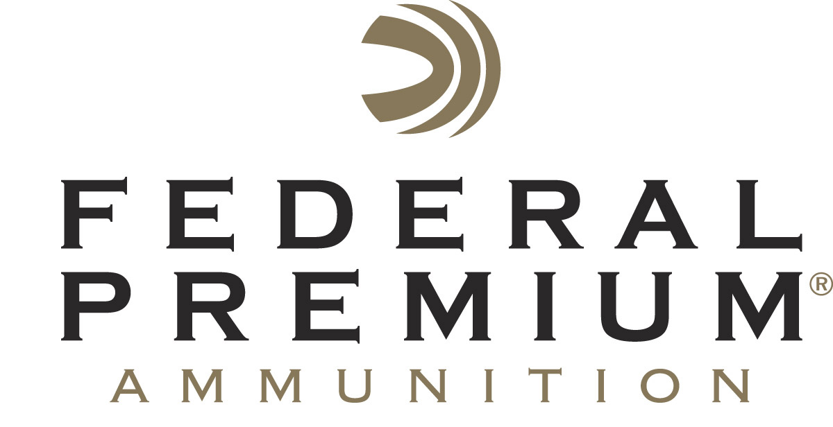
Contact: JJ Reich
Public Relations Specialist
763-323-3862
FOR IMMEDIATE RELEASE E-mail: pressroom@atk.com

Federal Premium® Safari Woodleigh® Hydro Wins Field & Stream Best of the Best Award

Federal Premium® Safari Woodleigh® Hydro Solids have earned a Field & Stream 2013 Best of the Best Award in the ammunition category. Woodleigh Hydro Solids feature an advanced solid design that produces massive wound channels with unmatched penetration for unquestionable dangerous game performance.

ANOKA, Minn. – July 18, 2013 – Federal Premium® Ammunition is proud to announce its new Safari Woodleigh® Hydro Solids have won a coveted Field & Stream 2013 Best of the Best Award. The loads were singled out because they feature the most advanced technology and the consistent performance required for once-in-a-lifetime shots in life-or-death situations.

“The winning products not only withstood our tough testing, but they stood head and shoulders above the rest, displaying absolute excellence in their field,” said Slaton White, Deputy Editor of Field & Stream. “The Best of the Best is the highest honor Field & Stream bestows on gear… worth your time, worth your money.”

“The Hydro Solid is built to give perfect straight-line penetration,” said David E. Petzal, Field & Stream Field Editor. “Tester John Blauvelt and I shot the Hydro Solids in 9.3x62 Mauser, the metric equivalent of the .375 H&H. They went through everything we could put in front of them. Everything.”

Mike Holm, Federal Premium’s Product Manager said hunters have long relied on solid, non-expanding bullets that blow through bone and thick hide when targeting the largest and most dangerous game.

“The new Woodleigh Hydro Solid offers that same unstoppable penetration while also creating a massive wound channel and large entry cavity that won’t seal,” Holm said.

Technology and Performance
The new Woodleigh Hydro Solid offers the unstoppable penetration of a solid, non-expanding projectile while also creating a devastating wound channel and large entry hole that won’t close. The solid copper-alloy bullet uses an advanced design with a concave nose positioned ahead of a flared pressure ring. Combined, these attributes create a low-pressure “cavitation bubble” that destroys tissue around the bullet and stabilize its line of travel through heavy bone. A special polymer cap protects and stabilizes the bullet until impact. The nose cap also ensures reliable cycling. The bullet features a grooved shank for match-grade accuracy and is loaded in a Federal Premium nickel-plated case for reliable, easy extraction.

Part No. Description MSRP
P370WH 370 Sako Magnum 286 grains $123.95
P9362WH 9.3x62 Mauser 286 grains $169.95
P9374WH 9.3x74R 286 grains $177.95
P375WH 375 H&H Magnum 300 $133.95
P416RWH 416 Rem. Magnum 400 grains $178.95
P416WH 416 Rigby 400 grains $264.95
P458WH 458 Win. Magnum 500 grains $188.95
P458LWH 458 Lott 500 grains $219.95
P470WH 470 Nitro Express 500 grains $314.95
P500NWH 500 Nitro Express 570 grains $314.95

See more information on this product, and learn about the complete lineup of Federal Premium products at www.federalpremium.com.

###

